**Practical: 2**

**Que:1 Write a Node.js program to create a console application to check**

**whether a user is eligible to sign-in or not based on age.**

const { Console } = require('console')

const readline = require('readline')

var rl = readline.createInterface(process.stdin, process.stdout)

rl.question('Enter Your Name : ', name =>

{

rl.question('Enter Your Age : ', age =>

{

rl.question('Enter Your Email Id : ', email =>

{

rl.question('Enter Your Mobile No. : ', mobile =>

{

if (age < 18)

{

var ag = 18 - age

console.log("Minimum required 18 years and your age is "

+ age + ", You should wait at least " + ag + " year(s)

more.")

}

else {

console.log("Great " + name + " you can sign in.\nUser

Name : " + name + "\nAge : "+age+" \nEmail ID : " + email

+ "\nMobile : " + mobile)

}

process.exit()

})

})

})

})

**Output:**

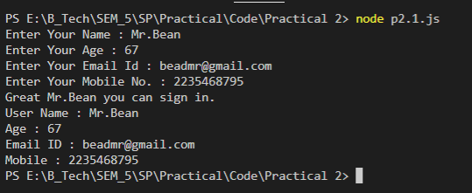

**Que:2 Write a Node.js program to create an object named book using object**

**literal syntax. Add book_title, author and publish_year as properties to**

**the book object and assign it’s appropriate values. Now create function**

**print_info() to print the book object to the console.**

const book = [

{

book_title : "Harry Potter and the Sorcerer's Stone",

author : "J.K. Rowling",

publish_year : 1997

},

{

book_title : "book2",

author : "author2",

publish_year : 2000

},

{

book_title : "book3",

author : "author3",

publish_year : 2003

}

]

function print_info(book1)

{

book1.forEach(element =>

{

console.log(element)

});

}

var b = new print_info(book)

**Output:**

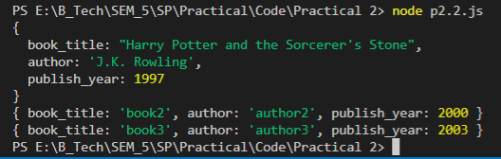

**Que:3 Create an array named products. Add objects to the array. Each object**

**should be a single product, with 3 properties: name, inventory and**

**unit_price. Create two functions named listProducts() and totalValue().**

**A listProducts() function accepts a parameter -- the array of products**

**and it should return an array of the names of the products. A function**

**named totalValue() should accept a parameter -- the array of products**

**and it should return the total value of all of the products in the array.**

**To calculate the total value of one product multiply the inventory value**

**with the unit_price.**

const products = [

{

name : "Pen",

inventory : 10,

unit_price : 15

},

{

name : "Pencil",

inventory : 10,

unit_price : 5

},

{

name : "Scale",

inventory : 10,

unit_price : 10

}

]

function listProducts(pro)

{

pro.forEach(element =>

{

console.log(element.name)

});

}

console.log("Product list")

var pn = new listProducts(products)

function totalValue(pro)

{

var total = 0

pro.forEach(element =>

{

total += element.inventory * element.unit_price

});

return console.log("Total value : "+total)

}

var tv = new totalValue(products)

**Output:**

